**Introduction & Design Brief**

The purpose of the project is to increase awareness for the decline of bee population “starting near the end of the 20th century”[1] as well as the impact of decrease in pollination. “The primary driver of change in pollinator communities is a change in land cover.”[2] The challenge our group faced was raising such awareness but also angling it towards change (see Figure 1).

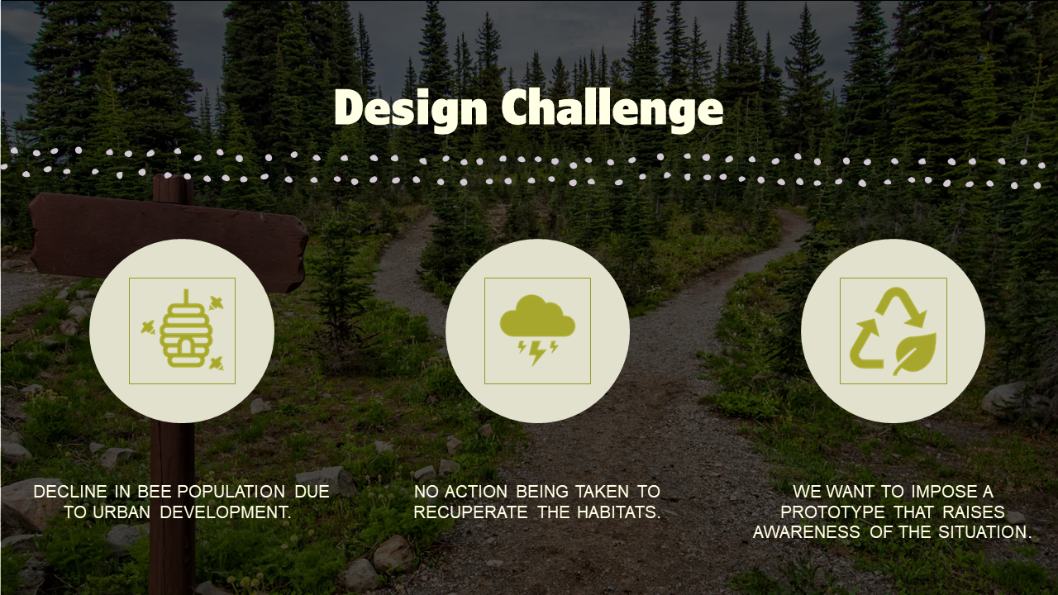

Figure 1 - Design Challenge Summary from Design Brief

The solution proposed in this report will be an interactive narrative created for mobile which forces the user to directly face the issues at hand. “The goal of interactive narrative is… to immerse users in a virtual world such that they believe that they are an integral part of an unfolding story.”[3] Placing a user in this “virtual world” thereby forces them to confront the issue head-on and through the method of an interactive narrative coerces users to decide whether they will act or not. Ultimately, having users question morality, triggering their emotional subconscious.

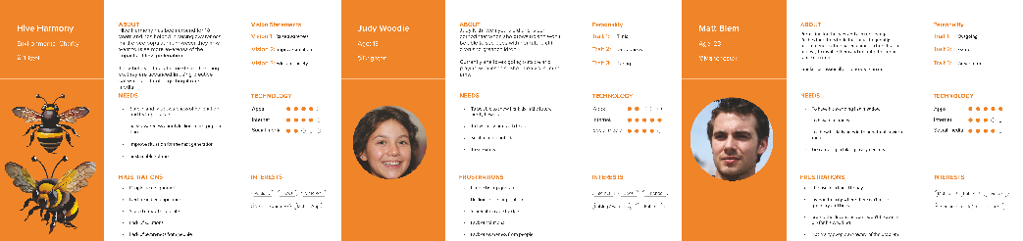

Figure 2 - User Personas

The idea of creating an app derived from the user personas displayed in Figure 2. Targeting such a young demographic allows for a more versatile approach due to their experience with media and mobiles.

**Initial Design Process**

Figure 3 - Flow Diagram

The early design process wireframed the flow of events that users could participate in when using the software displayed in Figure 3. With the intention of the app to educate users and reach a range of audiences, design was kept simple and intuitive as seen in Figure 4.

Figure 4 - Early Page Design

Each page design followed a colour palette reminiscent of bees due to the contrasting colours being accessible which was accompanied by an easy-to-read font in *Khula*.

Figure 5 - Whispers of a Withering Realm Storyboard

“Interactive narrative is the most ambitious art form existing today because it combines traditional narrative with visual art and interactivity.”[4] As seen in Figure 5, the story takes a rather linear approach with events leading from one to another. Cassie Phillipps from Pocket Gems states, “The data shows that having choices actually impactful to your storyline is not really a big deal.”[5] Many users want to be immersed into the game and feel like their choices have meaning, however more importantly they want a good narrative.

**Research**

Due to wanting the app to reflect a game and create an emotional response from the users, research was conducted into gamification – “the application of gameful or playful layers to motivate involvement within a specific context”[6] as well as research into [user interfaces](https://www.figma.com/file/oTzRQHuOcasXSGETI0GlC8/Interaction-Design?type=design&node-id=1%3A3&mode=design&t=kznGYosCXjx4O2EO-1) (UI) and interactive narratives as shown in Figure 6.

Figure 6 - User Interface & Interactive Narrative Research

With a goal of wanting to draw out an emotional response, the narrative of *Firewatch* & *The Walking Dead,* were great examples of games that have users question their morality resulting in quick emotional responses. While Phillipps is typically against adding morality system elements, she is also quick to state, “we don’t use them unless it really helps the story and if it helps the story it doesn’t hurt to put them in.”[7] Firewatch takes a rather impactful approach with having the audience face point-blank heavy decisions, similar to the approach of *Whispers of a Withering Realm.*

**Final Design Process**

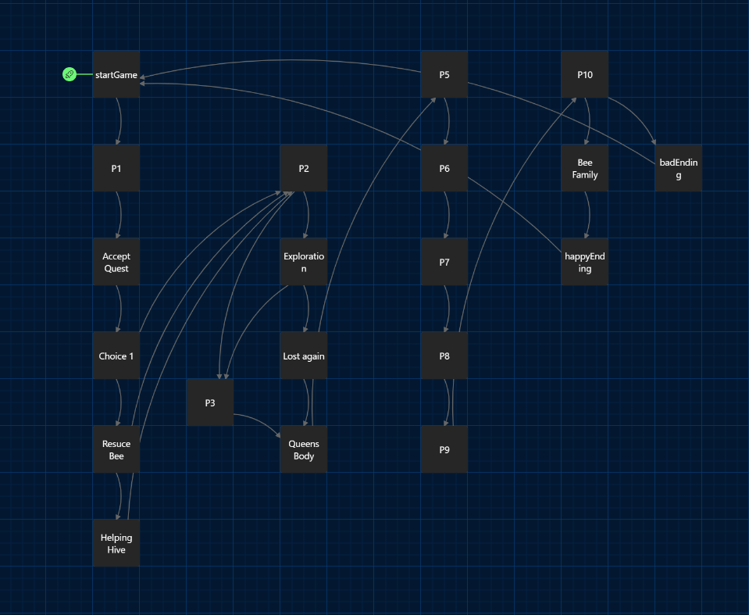

Figure 7 - Twine Branches

To create the [low-fi prototype](https://randumbfluke.github.io/Whispers_of_a_Withering_Realm/) for such an app, a narrative demo was created in T*wine* which involved branches stemming from one another as seen in Figure 7. While the narrative was not to be too complex due to wanting the young target audience to connect with the app, the narrative displays enough event choices to “allow someone other than the author to affect, choose, or change the plot”[8] as well “[give] narrative pleasure [that] can be generally described in terms of immersion in a fictional world.”[9]

Figure 8 - Twine Demo

Following the creation of the low-fi prototype, development on the [high-fi prototype](https://www.figma.com/proto/oTzRQHuOcasXSGETI0GlC8/Interaction-Design?node-id=27-302&starting-point-node-id=27%3A302&mode=design&t=87mFVcVolX0Y6kVs-1) began. Figure 9 showcases the applications layout and functionality before the final technical addition which will be reminiscent of The Walking Dead’s interactivity with their world. This interaction piece will be created in Unity to give users that step up in story engagement, having users participate in the physical world of the narrative.

Figure 9 - High-Fidelity Prototype

**Prototype Links**

[High-Fidelity Prototype](https://www.figma.com/proto/oTzRQHuOcasXSGETI0GlC8/Interaction-Design?node-id=27-302&starting-point-node-id=27%3A302&mode=design&t=87mFVcVolX0Y6kVs-1)

[Low-Fidelity Prototype](https://randumbfluke.github.io/Whispers_of_a_Withering_Realm/)

[Figma Board](https://www.figma.com/file/oTzRQHuOcasXSGETI0GlC8/Interaction-Design?type=design&node-id=1%3A3&mode=design&t=kznGYosCXjx4O2EO-1)

[Unity Demo](https://github.com/RandumbFluke/ID-Unity-Demo) (Technical Prototype)

[Unity Scene](https://github.com/RandumbFluke/ID-Unity_Scene)

[ID Video Showcase](https://youtu.be/B2T7AdEtO-k)

**References**

Fuchs, M., Fizek, S., Ruffino, P. and Schrape, N. (2014) *Rethinking gamification* [online]. Lüneburg : meson press. [Accessed 03 April 2024].

GDC (2019) All Choice No Consequence: Efficiently Branching Narrative. *YouTube* [online] 12 December. Available from: <https://www.youtube.com/watch?v=TEa9aSDHawA> [Accessed 04 March 2024].

LeBuhn, G. Luna, JV. (2021) Pollinator decline: what do we know about the drivers of solitary bee declines?. *Insect Science* [online]. 46, pp. 106-111. [Accessed 04 March 2024].

Meadows, MS. (2002) *Pause & Effect: The Art of Interactive Narrative* [online]. London: Pearson Education. [Accessed 04 March 2024].

Riedl, MO. Bulitko, V. (2013). Interactive Narrative: An Intelligent Systems Approach. *Association for the Advancement of Artificial Intelligence* [online]. pp. 67-77. [Accessed 04 March 2024].

Ryan, ML. (2009). From Narrative Games to Playable Stories: Towards a Poetics of Interactive Narrative. Storyworlds: A Journal of Narrative Studies [online]. 1 pp. 43-59. [Accessed 04 March 2024].

Zattara, EE. Aizen, MA/ (2021) Worldwide occurrence records suggest a global decline in bee species richness. *One Earth* [online]. 4, pp. 114-123. [Accessed 04 March 2024].

**Bibliography**

BMo (2020) 6 Minute PAUSE MENU Unity Tutorial. *YouTube* [video]. 18 May. Available from: <https://www.youtube.com/watch?v=9dYDBomQpBQ> [Accessed 24 April 2024].

Code Monkey (2022) How to Talk to NPCs! (or Interact with any Object, Open Doors, Push Buttons, Unity Tutorial). *YouTube* [video]. 12 October. Available from: <https://www.youtube.com/watch?v=LdoImzaY6M4&t=1166s> [Accessed 24 April 2024].

Goulson, D. Nicholls, E. Botias, C. Rotherray, E. (2015). Bee declines driven by combined stress from parasites, pesticides and lack of flowers. *Science* [online]. 347 (6229). [Accessed 04 March 2024].

iHeartGameDev (2021) How to Move Characters in Unity 3D: Animated Movement Explained [Built-In Character Controller #2]. *YouTube* [video]. 30 May. Available from: <https://www.youtube.com/watch?v=bXNFxQpp2qk> [Accessed 20 April 2024].

iHeartGameDev (2022) How to Program in Unity: Third Person Movement Explained. *YouTube* [video]. 09 October. Available from: <https://www.youtube.com/watch?v=-shDcRpTypk&t=160s> [Accessed 24 April 2024].

SpeedTutor (2023) Creating Notes & Letters In Unity -- UI & Raycast Tutorial. *YouTube* [video]. 15 April. Available from: <https://www.youtube.com/watch?v=cMTCx4_5Jqc&t=493s> [Accessed 24 April 2024].

1. Zattara, EE. Aizen, MA/ (2021) Worldwide occurrence records suggest a global decline in bee species richness. pp. 114-123.
2. LeBuhn, G. Luna, JV. (2021) Pollinator decline: what do we know about the drivers of solitary bee declines?. pp. 106-111.
3. Riedl, MO. Bulitko, V. (2013). Interactive Narrative: An Intelligent Systems Approach. pp. 67-77.
4. Meadows, MS. (2002) *Pause & Effect: The Art of Interactive Narrative* [online]
5. GDC (2019) All Choice No Consequence: Efficiently Branching Narrative.
6. Fuchs, M., Fizek, S., Ruffino, P. and Schrape, N., 2014. Rethinking gamification (p. 289).
7. GDC (2019) All Choice No Consequence: Efficiently Branching Narrative.
8. Meadows, MS. (2002) *Pause & Effect: The Art of Interactive Narrative*
9. Ryan, ML. (2009). From Narrative Games to Playable Stories: Towards a Poetics of Interactive Narrative. pp. 43-59.